**

**MATHEMATICS:**

**SPECIALIST 3 & 4**

**SEMESTER 1 2018**

**TEST 3**

**Calculator Free**

Reading Time: 2 minutes

Time Allowed: 23 minutes Total Marks: 19

**1.** [4, 1 marks]

The lines with equations $r=\left(\begin{matrix}4-λ \\ -2+3λ \\ 1+λ\end{matrix}\right)$ and $r=\left(\begin{matrix}3-5λ \\ 5-λ \\ 5-7λ\end{matrix}\right)$ both lie in the same plane.

(a) Determine the equation of the plane in the form $r∙n=c$.

(b) Determine the Cartesian equation of the plane.

**2.** [7 marks]

On a beautiful Sunday morning on a bleak, desolate planet, Spaceman Spiff is flying in a straight line with vector equation $r\left(t\right)=\left(-2i+4j+7k\right)+t(5i-3j+k)$ kilometres per minute. Unbeknownst to Spaceman Spiff, a Mangzarr Beast fires a rocket that travels according to the vector equation $r\left(t\right)=\left(5i+j+2k\right)+t(2i-4j+3k)$ kilometres per minute.

Determine the closest distance that the rocket gets to Spaceman Spiff.

**3.** [4, 3 marks]

(a) Solve the system of equations

$4x+3y + z =1$

$2x- y +3z=3$

$x+3y - z =1$

(b) Consider the three planes defined by the equations:

$4x+3y + z =1$ Plane $1$

$2x- y +3z=3$ Plane $2$

$kx+3y - z =1$ Plane $3$

Determine the value for $k$ that would represent the situation where Plane $2$ is parallel to Plane $3$, with Plane $1$ intersecting both planes.

**

**MATHEMATICS:**

**SPECIALIST 3 & 4**

**SEMESTER 1 2018**

**TEST 3**

**Calculator Assumed**

Reading Time: 2 minutes

Time Allowed: 33 minutes Total Marks: 31

**4.** [1, 1, 3, 3 marks]

Given the vectors $p=\left(\begin{matrix}2 \\ 3 \\ -2\end{matrix}\right)$ and $q=\left(\begin{matrix}-2 \\ 4 \\ 3\end{matrix}\right)$, determine

(a) the angle between the two vectors, to the nearest degree,

(b) the angle, to the nearest degree, between vector $p$ and the $y$-axis,

(c) a vector of length $12$ units in the direction $p+q$,

(d) the exact area of the triangle formed by the vectors $p$ and $q$.

**5.** [3, 3 marks]

A particle travels according to the equation $r=2\cos{t}i+(2-3\sin{t})j$.

(a) State the Cartesian equation of the path of the particle.

(b) Sketch the path of the particle for $0≤t≤\frac{3π}{2}$ on the axes below.

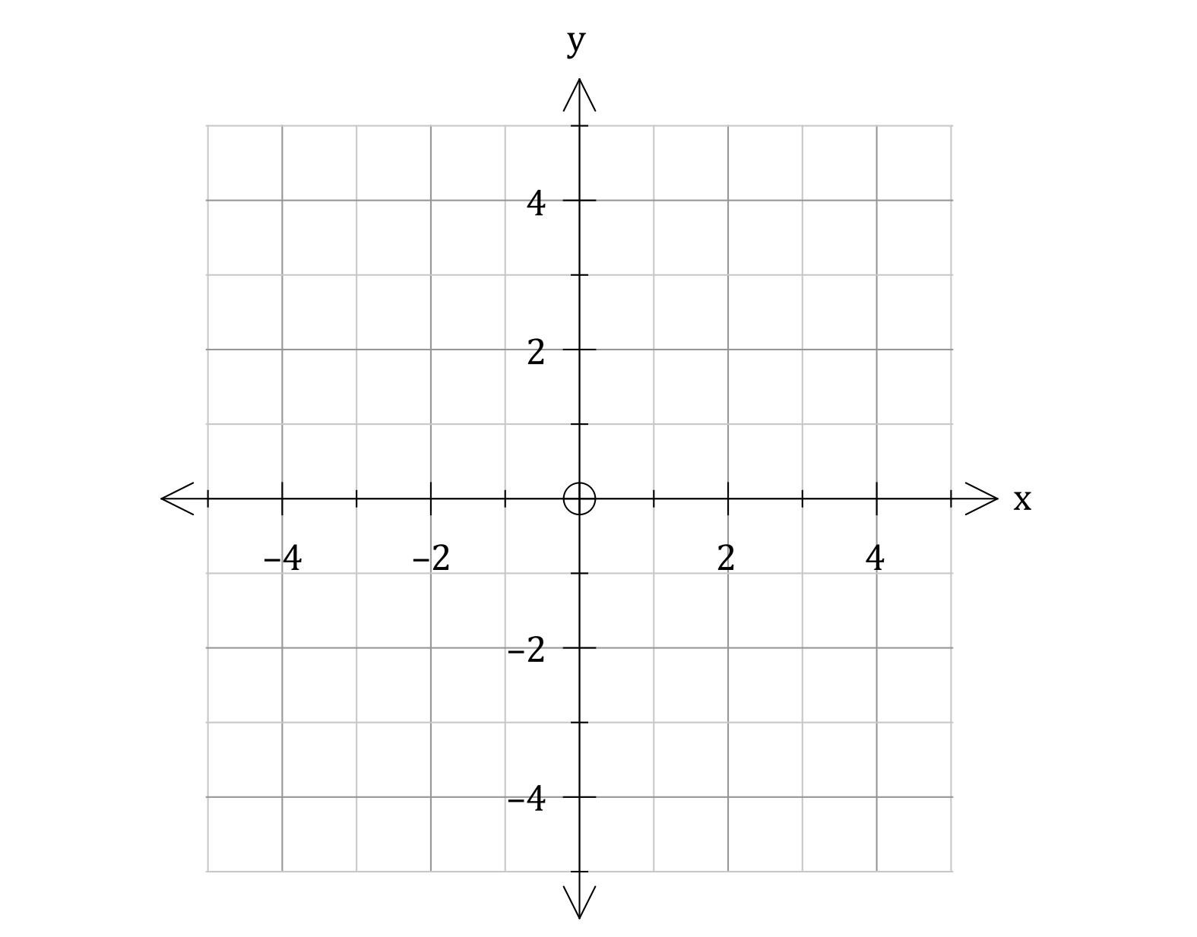

**6.** [1, 5, 2 marks]

A plane has Cartesian equation $5x+3y-z=7$.

(a) Determine the normal equation for the plane.

A sphere has equation $\left|r-3i+6j+2k\right|=7$.

(b) Determine the exact distance from the plane to the centre of the sphere.

(c) Determine the Cartesian equation of a second plane that is parallel to the plane above, and contains the centre of the sphere.

**7.** [5, 4 marks]

A sphere has the vector equation $\left|r-(4i+3j+k)\right|=\sqrt{83}$.

(a) Determine the coordinates of the points, $P_{1}$ and $P_{2}$, where the line given by the equation

$r=\left(λ-4\right)i+\left(2λ-12\right)j+\left(2λ-16\right)k$ intersects the sphere.

(b) Points $P_{3}(-5, 4, 2)$ and $P_{4}(-1, -4, 4)$ also lie on the sphere. Determine the angle that the points $P_{3}$ and $P_{4}$ subtend at the centre of the sphere.

Give your answer in radians to $2$ decimal places.